

**Department of Computer Science &Engineering(CSE)**

Name : Shah Ibne Fahad

Student ID : C193048

Semester : 7th

Section : 7BM

Email : c193048@ugrad.iiuc.ac.bd

Contact : 01860793742

Course Code : CSE-4742

Course Title : Computer Graphics Lab

Name of the course Teacher :

**Mahadi Hassan**

Associate Professor

Dept of Computer Science and Engineering,IIUC

1. **Draw a line, circle, rectangle:**

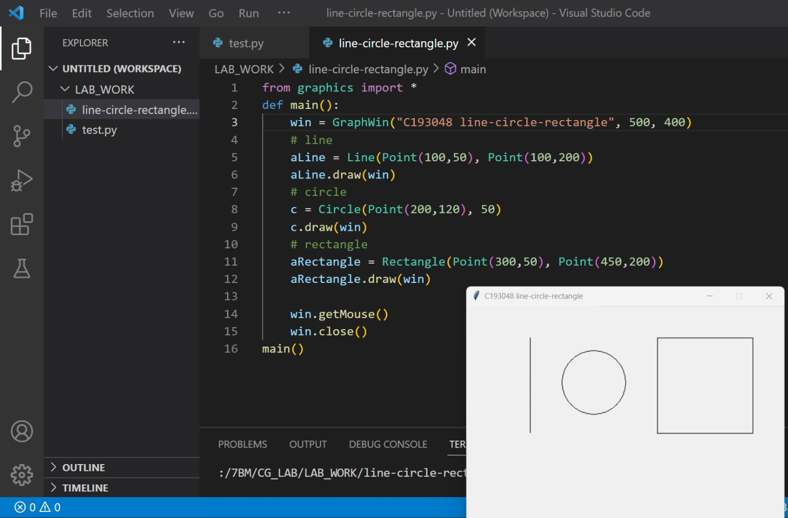

1. **Draw A, B :**

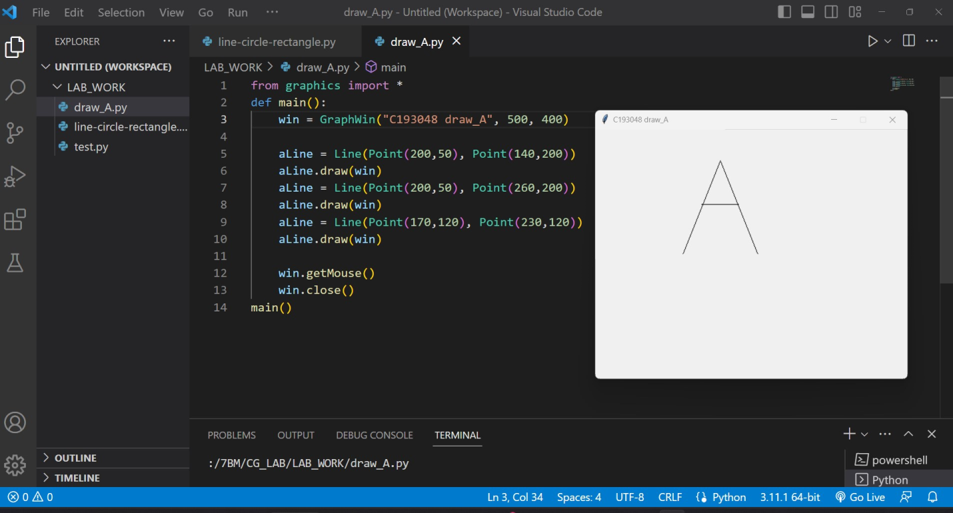

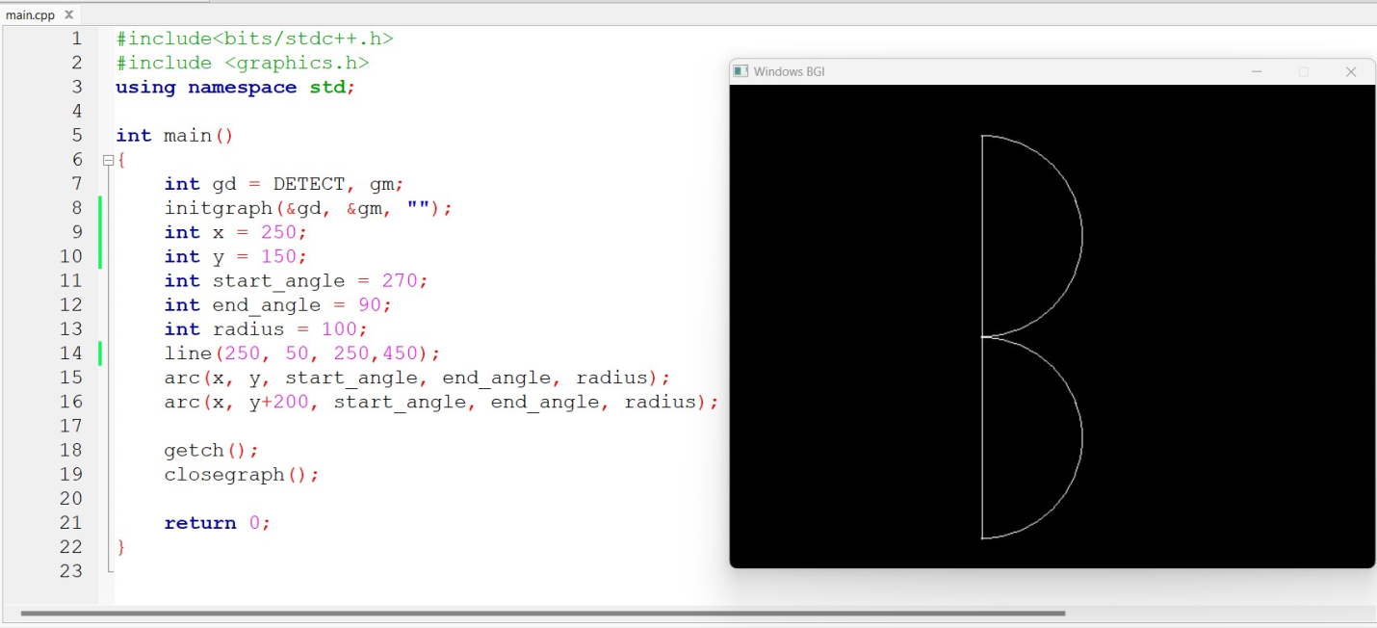

1. **Draw Bangla Ka, Kha :**

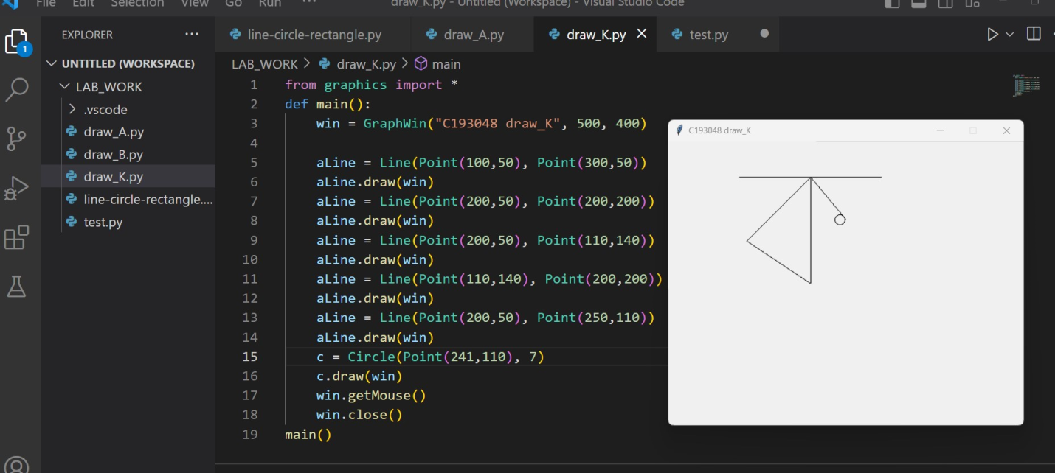

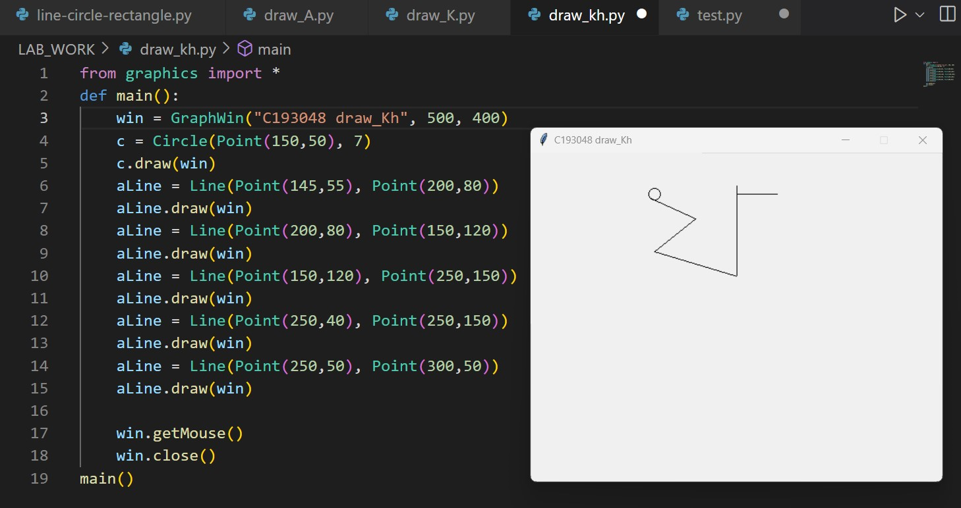

1. **Draw smiling face :**

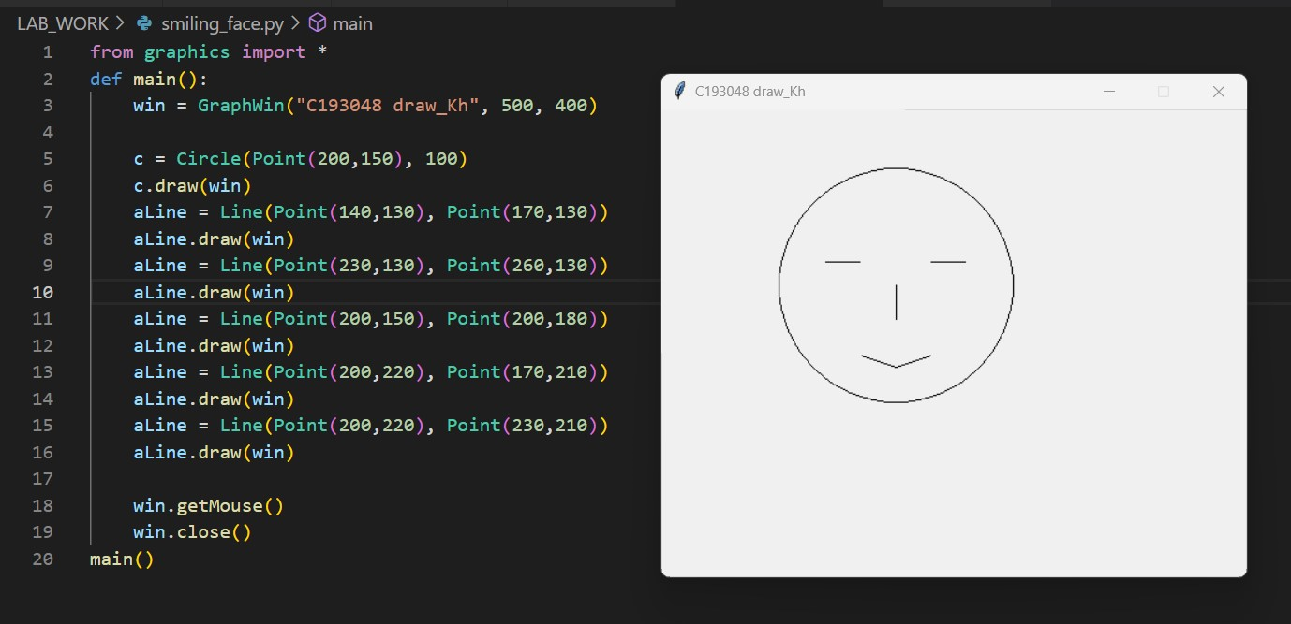

1. **Draw Bangladeshi Flag :**

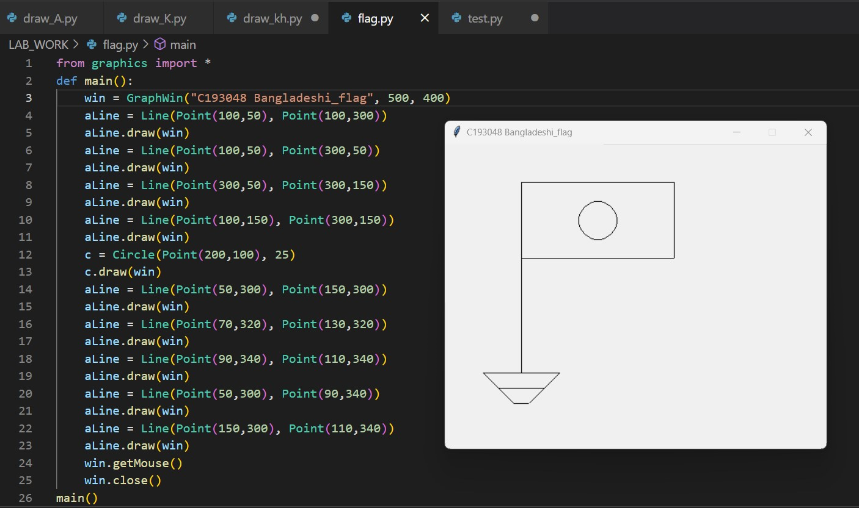

1. **Draw Shahid Minar :**

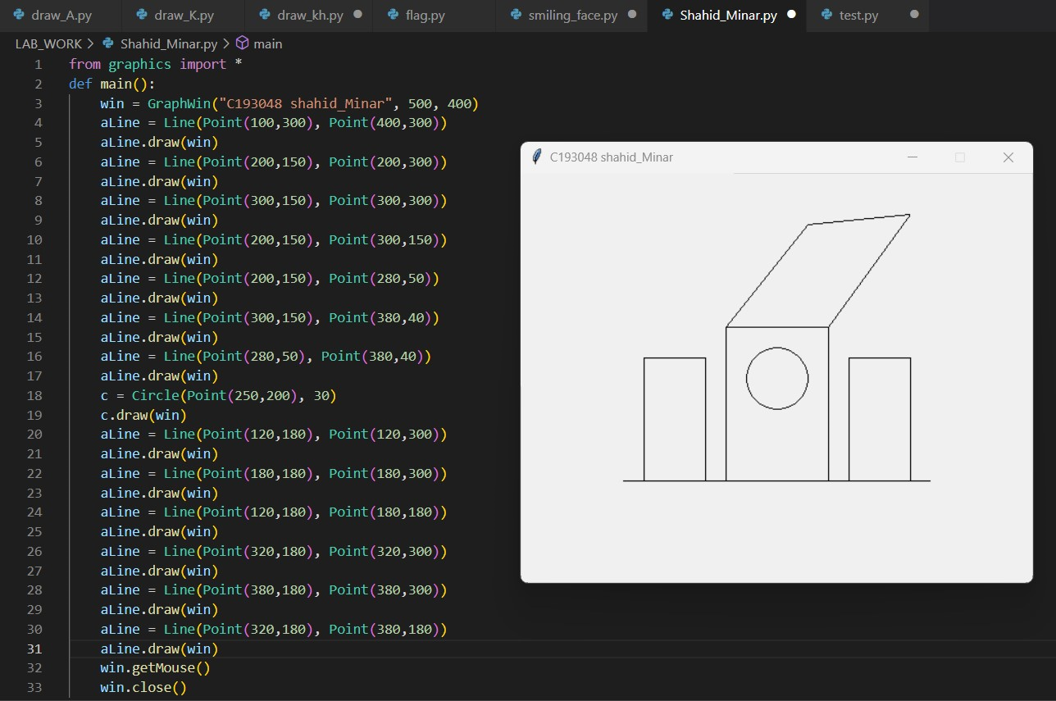

1. **Draw Sriti Shoudho :**

